

Empowering your enterprise with
award winning services
Requirement Summary
BFSI CUSTOMERS
Bengaluru
01-12-2025| QS/2025-26/AWS SBU/Sow/01.0



Empowering your enterprise with
award winning services
Services Proposal for
<Customer Name>
<DD-MMM-YY> | <Ver1.0> | QS/2024-25/<CityCode>/SoW/<CustomerCode><DocNum>
Date | Version | Author



Empowering your enterprise with
award winning services
Services Proposal for Migration
Customer name
Bangalore
01-Aug-24 | QS/2024-25/AWS SBU/SoW/ABC/01.01
AWS



Empowering your enterprise with
award winning services
Services Proposal for
<Customer Name>
<DD-MMM-YY> | <Ver1.0> | QS/2024-25/<CityCode>/SoW/<CustomerCode><DocNum>
Date | Version | Author



Empowering your enterprise with
award winning services
Requirement Summary
LGB
Coimbatore
03-06-2025| QS/2025-26/AWS SBU/Sow/01.0



Empowering your enterprise with
award winning services
Services Proposal for
<Customer Name>
<DD-MMM-YY> | <Ver1.0> | QS/2024-25/<CityCode>/SoW/<CustomerCode><DocNum>
Date | Version | Author



Empowering your enterprise with
award winning services
Services Proposal for Migration
Customer name
Bangalore
01-Aug-24 | QS/2024-25/AWS SBU/SoW/ABC/01.01
AWS



Empowering your enterprise with
award winning services
Services Proposal for
<Customer Name>
<DD-MMM-YY> | <Ver1.0> | QS/2024-25/<CityCode>/SoW/<CustomerCode><DocNum>
Date | Version | Author



Non-disclosure of confidential information
This proposal is being provided to you as a measure of your interest in entering a services contract with Quadra.net (India) Private Limited. (“Quadra”) The information provided in this document must be solely used to determine the suitability of such an arrangement. Each recipient who reads this proposal agrees, that prior to reading this proposal, he/she shall not distribute or disclose the information contained herein for any purpose other than those stated.
This proposal shall remain the sole property of Quadra and may not be copied, reproduced, or distributed without the prior written consent of Quadra. In furnishing this proposal, Quadra undertakes no obligations. This proposal states general intent and agreement to perform services contingent upon a formal written agreement between both parties.

Disclaimer
The information contained in this document represents the current view of Quadrasystems.net (India) Private Limited (“Quadra”) as on date and is subject to change at any time without notice to you. This document and its contents are provided AS IS without warranty of any kind and should not be interpreted as an offer or commitment on Quadra. We make no warranties, express or implied, in this document.
The descriptions of other companies’ products in this document, if any, are provided only as a convenience to you. Any such references should not be considered an endorsement or support by Quadra. Quadra cannot guarantee their accuracy, and the products may change over time. Also, the descriptions are intended as brief highlights to aid understanding, rather than as thorough coverage. For authoritative descriptions of these products, please consult their respective manufacturers.
This deliverable is provided AS IS without warranty of any kind and Quadra MAKES NO WARRANTIES, EXPRESS OR IMPLIED, OR OTHERWISE.
All trademarks are the property of their respective companies.

Revision History

Change Record
Date | Author | Version | Change Reference
01-12-2025 | Nikhil MS  nikhil.ms@quadrasystems.net | 01.0 | Initial draft for review/discussion

Reviewers
Date | Author | Version
01-12-2025 | Tamizharasan Natarajan  tamizharasan.n@quadrasystems.net | 01.0

Table of Contents
Requirement Summary 5
Solution 5

Requirement Summary
The goal is to build a demo of an AI-powered merchant onboarding system for Indian-registered merchants, replacing manual KYC/KYB processes with an automated multi-agent pipeline. The system uses AWS Bedrock (Amazon Nova Pro) to orchestrate six Lambda-based agents — covering document collection, OCR extraction, entity routing, KYC/KYB verification, AML screening, and final recommendation — coordinated via Step Functions. The demo validates the end-to-end flow for core Indian compliance checks (PAN, GSTIN, CIN, Aadhaar, AML) across key entity types, with results stored in DynamoDB and merchant notifications sent via SES.
Key Requirements:
- Multi-Agent Orchestration via Bedrock Nova Pro: Six Nova Pro-powered Lambda agents coordinated through Step Functions Express — Supervisor Agent routes merchants through the correct verification pipeline based on entity type; Recommendation Agent produces a structured approve/reject/escalate decision.
- India-Specific KYC/KYB Verification: Integrate with Surepass/IDfy/Karza APIs to verify PAN, Aadhaar eKYC, GSTIN, CIN, and Director DIN — covering Proprietorship and Private Limited as the two primary demo entity types.
- AML and Sanctions Screening: Screen merchant and key persons against PEP lists, sanctions lists, and India ED watchlist via IDfy AML — with hard-block logic on hits and EDD flag on medium-risk results.
- Bank Account Verification: Penny drop via Cashfree VRS or Setu to confirm account holder name matches PAN before approval.
- Document Storage and OCR: Upload documents to S3; Agent 2 extracts and cross-validates key fields (PAN name vs bank account name vs GST legal name) using IDfy/HyperVerge OCR API before any verification begins.
- Audit Trail and Reporting: All agent decisions and check results written to DynamoDB (single-table); final compliance report stored as JSON in S3; merchant notified of decision via SES.

Solution
- Intake: API Gateway HTTP API receives merchant form data and document uploads → Lambda Intake Handler stores docs to S3 and triggers Step Functions Express workflow.
- Step Functions Express Workflow: Runs Agent 1 (doc validation) → Agent 2 (OCR + extraction) → Agent 3 (Nova Pro supervisor + entity routing) → parallel execution of Agent 4 (KYC/KYB API calls) and Agent 5 (AML screening) → Agent 6 (Nova Pro recommendation).
- Secrets and Config: All third-party API keys (Surepass, IDfy, Karza, Cashfree, ComplyAdvantage) stored in AWS Secrets Manager; each Lambda retrieves at cold start.
- Output: Agent 6 writes final decision to DynamoDB, saves report to S3, triggers SES email to merchant with approve/reject/escalate result and reason.
- Observability: CloudWatch Logs across all Lambda functions and Step Functions execution history for demo tracing and debugging.

Architecture
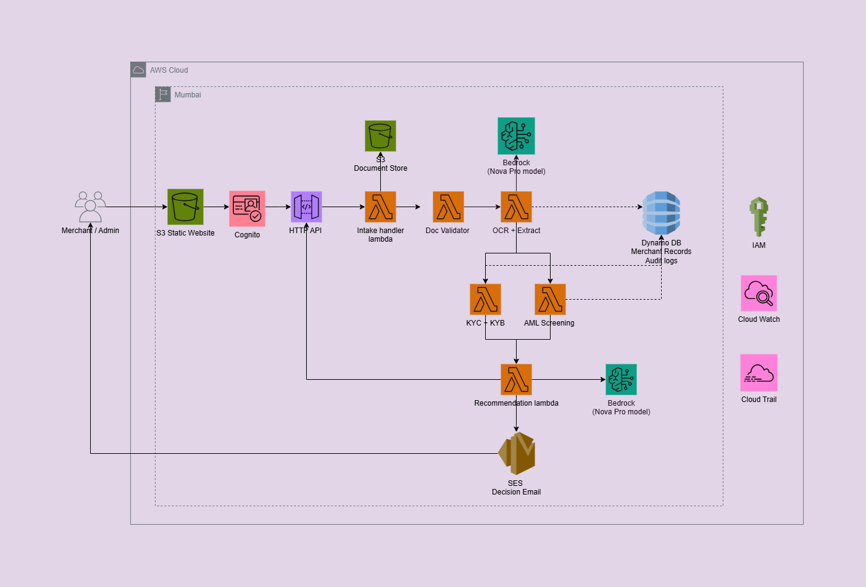

Architecture considerations
- The deployment is configured in the Mumbai region (ap-south-1) to comply with RBI data localization requirements, ensuring all merchant data and compliance records remain within Indian jurisdiction.
- Amazon S3 hosts the static web portal for merchants to submit onboarding applications and for payment providers such as PhonePe and Razorpay to monitor merchant status and handle escalations — no web server required.
- Amazon Cognito manages authentication for three user types — merchants, payment providers, and administrators — ensuring role-based access control across the portal and restricting each user to only what they are permitted to see.
- AWS Lambda powers all five agents — document validation, OCR extraction, KYC/KYB verification, AML screening, and recommendation — each stateless, independently scalable, and invoked sequentially or in parallel as the workflow requires.
- AWS Bedrock (Nova Pro) is used at two points — Agent 2 for multimodal document field extraction, and Agent 5 for reasoning over all verification results to produce a structured approve/reject/escalate decision.
- Amazon S3 also stores raw merchant document uploads and final compliance report outputs, with server-side encryption enabled by default to protect sensitive KYC data at rest.
- Amazon DynamoDB stores merchant records, per-step agent status, and the full audit log — powering the real-time status UI that reflects live pipeline progress to the merchant as each agent completes.
- Amazon SES sends automated decision emails to merchants on onboarding completion, with escalation cases copied to payment provider compliance teams for immediate action.
- IAM roles enforce least-privilege access for every Lambda function, restricting each to only the permissions it needs — S3, DynamoDB, Bedrock, or SES — with no over-privileged access to merchant data.
- Amazon CloudWatch captures logs across all Lambda functions — agent durations, API call outcomes, Nova Pro response times, and decision events — providing full traceability for every onboarding session.
- Mock verification APIs simulate all KYB and AML checks — PAN, GSTIN, CIN, Aadhaar, penny drop, PEP, sanctions, and ED watchlist — using fuzzy name matching against fake databases, replicating real vendor API behaviour without third-party costs.

